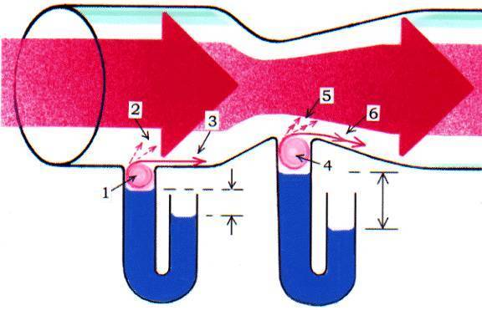

1. Turbulence cause by frictional force is produced. (Just like blowing a bottle)
2. The centrifugal force attempts to throw fluid’s molecules out of their orbit.
3. The fluid’s molecules are drawn from the U-shaped tube by frictional force.
4. When the fluid moves faster, the turbulence is stronger.
5. The centrifugal force is also stronger.
6. More of the fluid’s molecules are drawn from the U-shaped tube.

Because of gravity, the frictional force is always present which creates the invisible actions described above and cause low pressure which lifts the liquid in the U-shaped tubes. The liquid levels do not indicate the pressure of the moving fluid. Bernoulli’s Principle stated that “A moving fluid has low pressure-the faster a fluid moves, the lower its pressure” is widely misunderstood and mistakes. The moving fluid is unable to display its pressure in the U-shaped tubes because the centrifugal forces above the turbulences are the active barriers of the U-shaped tubes. More exactly, some molecules of the moving fluid will be dropped in (U-shaped tube) and some will be thrown out, keeping them balanced to the liquid’s weight.

By Mity Wongkit

ELECTRIC DIAGRAM

A & C = Conductors, carrying the current (Ampere) and electro motive force (Volt). The electric current completes its circuit via ground wire (not shown).

B = Resister or load (Ohm) creates voltage drop and limits the current.

VENTURI CHANNEL

A & C = Main Channels compare as electric conductors.

B = Constriction is compared as the resister on the electric circuit. The narrower constriction = the higher resistance that creates more pressure drop or voltage drop and limits its current.

Wide Red-arrows are represented current of the fluid compared to “Ampere” on electric circuit, they run stable-volume; speed is variable and completes its circuit via atmosphere or returning loop.

Fine Red-arrows are represented the pressure potential or motive force compared to electric as “Volt” when presented, it forces the stationary fluid to move as a current; and will be dropped by the size of the blockage (constriction or resistance). The source may be generated by blower, vacuuming, pump, gravity or atmosphere. This force had been neglected together with frictional and liquid molecular-cohesive forces.

The friction on inner surface of the tube compares as internal resistance of the conductors on electric circuit.

The liquid levels are compared as temperature rising on electric circuit and it is higher at the resister.

The last drawing on this page is the complete component of the Venturi Channel which will be used to discuss on this article.

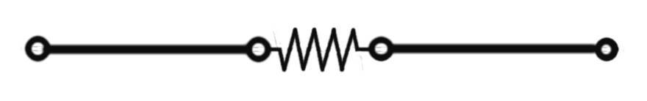
A B C

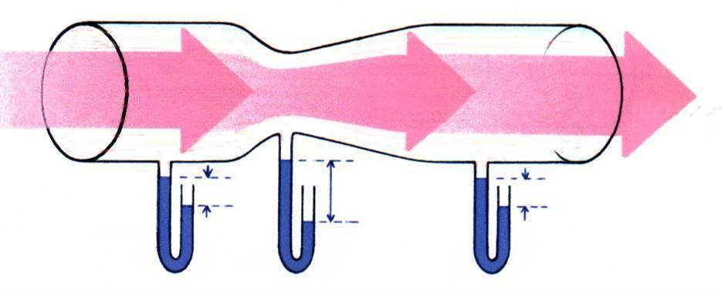
A B C

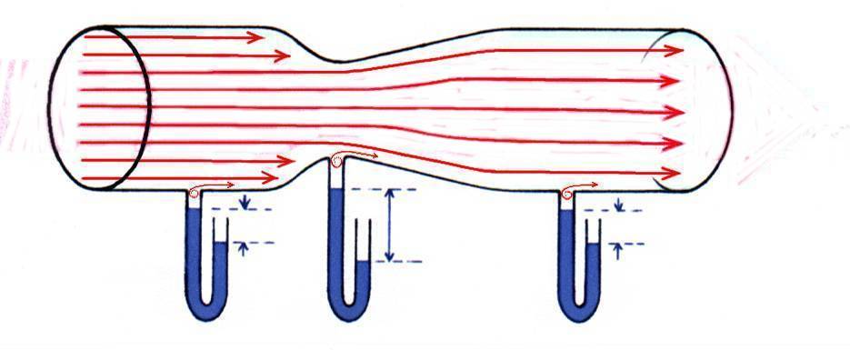

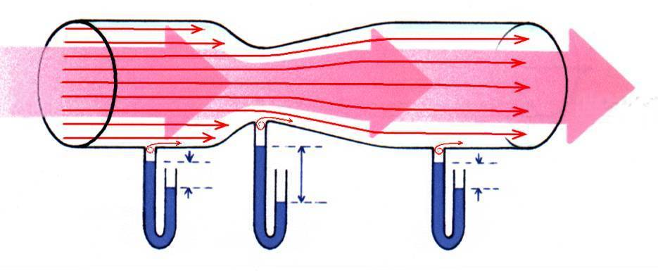

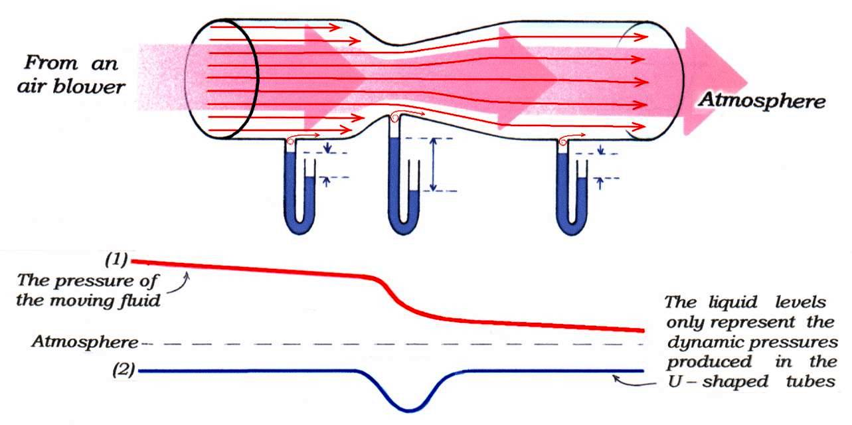

The above drawing depicts Venturi's constricted channel of flow. When fluid flows through this channel, it lifts the liquid in the U-shaped tubes. Because the speed of flow at the point of constriction is greater than at the other points, the liquid level in the U-shaped tube at that point drops. This phenomenon has led us to believe that a moving fluid has low pressure. The more rapidly a fluid moves, the lower its pressure. This seems contrary to common sense. Why does a fluid lose its pressure when it moves? There is no reasonable answer to this question. It feels untrue when standing against strong winds or currents. For an example, gases in a gun barrel move extremely fast under very high pressure.

On February 2, 2001: Professor Kenneth L. Menningen of the University of Wisconsin-Whitewater explained that, “There is a very high pressure along the length of the barrel, but perpendicular to the barrel the pressure is low. One way to view this is that the molecules are too ‘busy’ going down the barrel to impact the sides of the barrel very often. Fewer impacts translates to lower pressure.” If this is true, gas-operated guns would not work, because most of them have gas ports perpendicular to their barrels. It appears that there is no suction as seen on Venturi’s tube but gas discharges at the gas port to operate gun’s mechanism. Also a common situation contrary to the explanation above is a jet of water runs out from a hole on the side of the damaged garden hose while the water is running. If the pressure is low perpendicular to the hose. Why doesn’t it suck the air in through the hole? This issue has occurred because of people have been fooled by the liquid levels in the U-shaped tubes or columns. The below drawing is an example that the Ruger Mini 14 rifle also has the gas port perpendicular to its barrel.
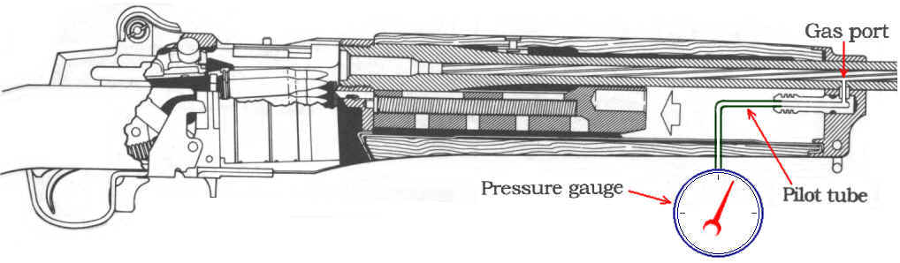

Drawing courtesy of Sturm, Ruger & Company, Inc., reproduced by permission.

Some one who does not understand this concept might say “When I fire a gas operated auto gun, I do not believe there is a turbulence produced in the gas port that has the same configuration as described previously.
This is true, because the pressure of the gas port is lower than its critical pressure. If a pressure gauge is connected to the gas port via a pilot tube to prevent gas leakage which comparable as it were the liquid that clogs the U-shaped tube as shown in the above drawing, when the gun is fired, gases will enter the gas port, build up pressure in the pilot tube until it reaches a critical pressure, and the turbulence will be started. But it maybe not happened, because a gun fire takes only a short duration. The critical pressure is what we have to do more study.
Similarly, a jet of water runs out from a hole on the side of the damaged garden hose, because the pressure in the hose at that point is higher than outside. If a tall vertical tube is hooked up to the hole as a column, then the water will enter the column and build up weight until it reaches a critical point when the turbulence starts.

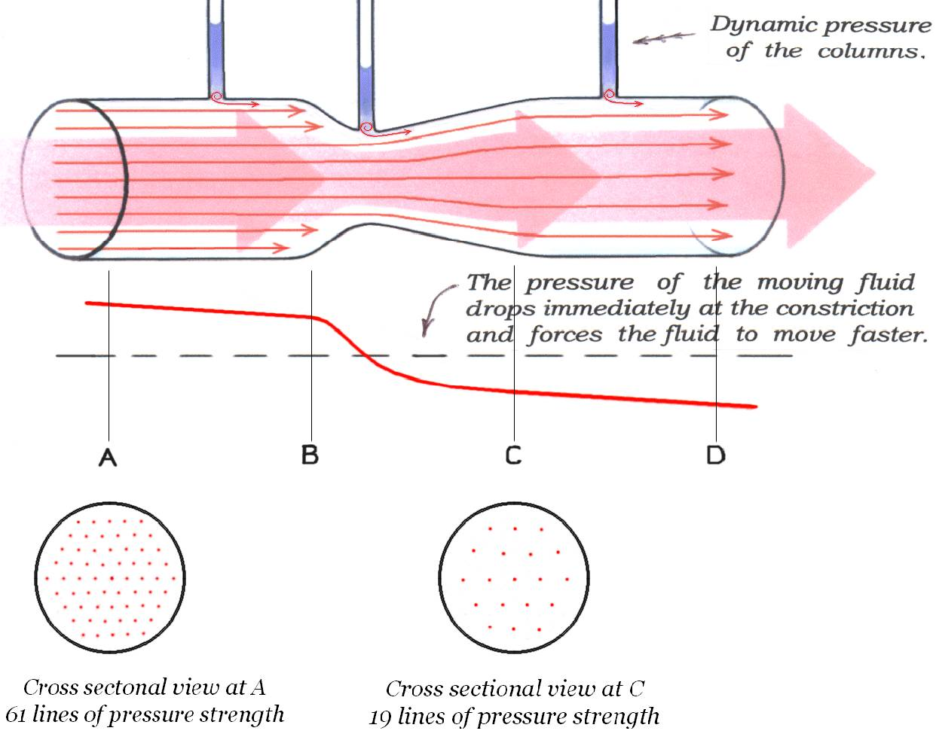

Above drawing: When a motive force is presented in the channel, stream runs through the constricted channel. The red graph represents the pressure of the moving fluid and indicates that the sections A-B and C-D have the same rate of pressure drop, so the fluid travels at the same speed. The rate of pressure drop is greater at section B-C, because the pressure of the moving fluid (motive force) is partially blocked by the constriction, as represents by fine red arrows, 4 out of 9 lines of pressure potential (motive force) are blocked and only 5 lines of them are able to pass through the constriction then distribute their pressure as they enter the un-constricted section of the channel. (If look into the cross sectional view at sections A and C; we see 42 out of 61 lines of pressure potential are blocked, only 19 pass.) The blockage at the constriction creates a greater pressure potential difference between the left and right sections and forces the fluid to move faster at the constriction than section A-B and C-D, since the speed of the moving fluid is controlled by its pressure (not the pressure is controlled by its speed). The higher the pressure potential difference, the higher its speed, from a location to another location attempting to equalize the difference. (That is why gases in a gun barrel move extremely fast.) The liquid levels in the columns (or U-shaped tubes) reflect the dynamic pressure produced in the columns themselves, but not the pressure of the moving fluid. These levels do support Bernoulli's laws relating to dynamic pressures as a function of fluid speed.

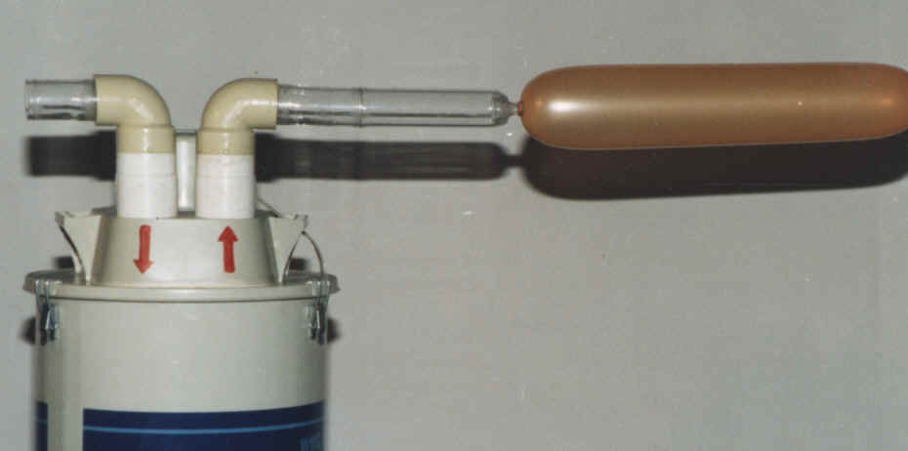

Above photo: The output of the air blower produces high pressure that inflates a balloon.

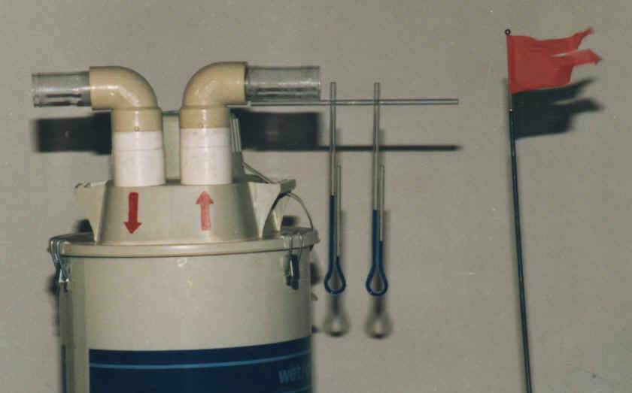

Above photo: The output of the air blower changes the liquid levels in the U-shaped tubes. When air flows; the liquid levels show that pressures are low and that the pressure is lower in the tube nearest the output since the air there moves faster. The liquid levels show that air moves from low pressure to high pressure. This is contrary to our understanding of nature and virtually impossible. This is also proof that the liquid levels are not a function of the pressure of the moving air which passes over the U-shaped tubes, (only a function of its speed). Fluid under pressure tends to equalize that pressure with its surroundings. Machines such as engines, hydraulics and firearms work under this natural law of pressure equalization. Fluids under high pressure move toward low pressure areas, while the reverse is never seen. This law appears to have been ignored. In addition, frictional and liquid molecular-cohesive forces are not accounted for in the Venturi Effect.

Nature itself provides an example. Although the friction of moving air on water is slight, it can creates waves. With sufficient wind speed, waves may be carried onto land. As wind speed is increased, frictional force is also increased.

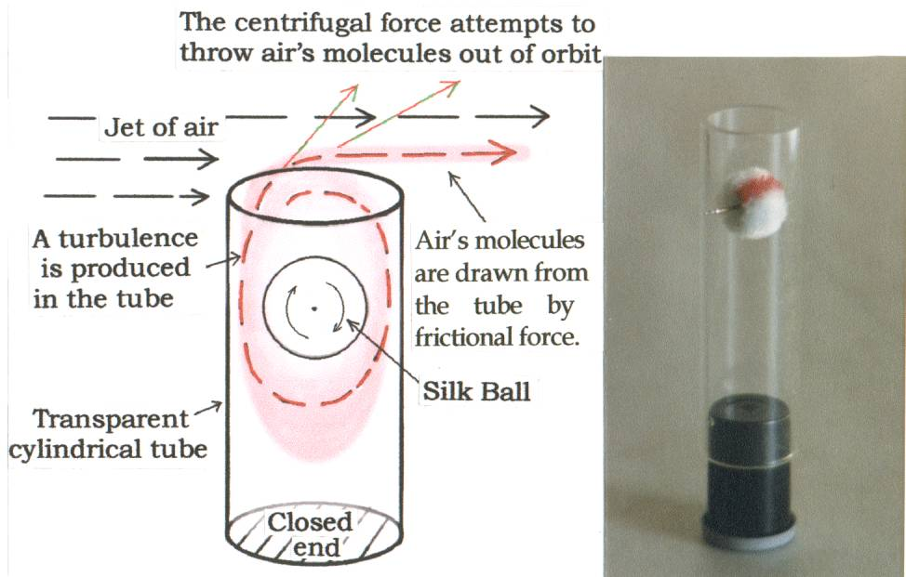

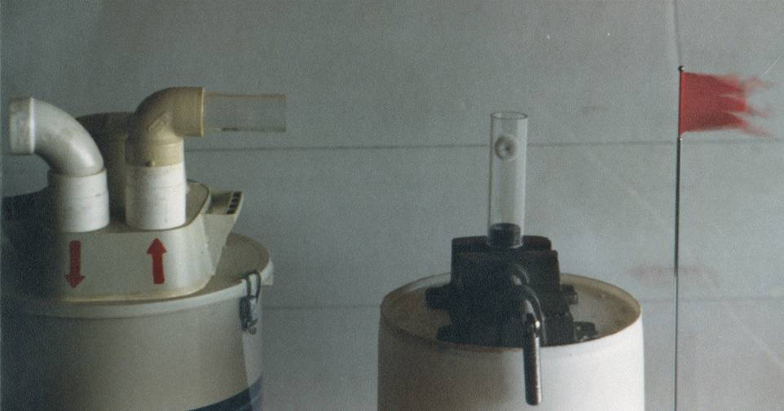

Above photos: In an experiment, a silk ball is placed on a shaft in a transparent tube so that the ball is below the level of the tube’s open end and any flow that passes over it. The other end is closed. The open end of the tube aligned with air flow as shown in the photos. When the air blower is switched on, the ball spins at a high speed. This proves that when a fluid moves across the open end of a tube, the turbulence is produced within the tube. At the same time, the centrifugal force acts to throw the fluid molecules out of their orbital path and together with the passing fluid draws the fluid from the tube by friction and causes a low pressure in the tube. This will occur even in the small tubes because fluid’s molecules are very fine.

Blowing a whistle, a flute or a bottle creates turbulence and generates sound. This is a well known phenomenon that has the same principle.

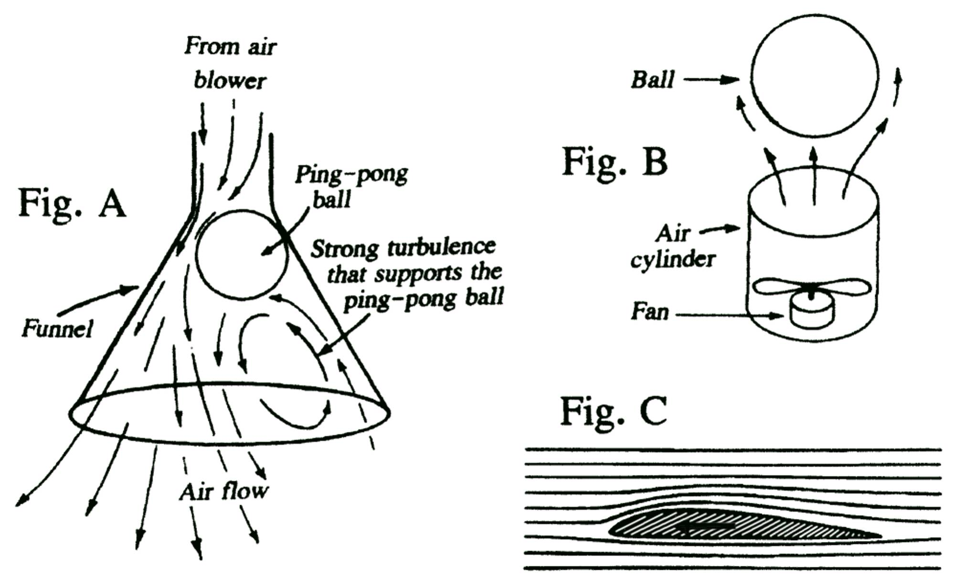

Fig. A, depicts a demonstration in which a funnel is attached to a hose which is connected to an air blower. A ping-pong ball is placed in the cone of the funnel so that it will be held and moves around at the funnel's bottom. The accepted explanation states that the air flow at the bottom of the funnel moves faster than the air at the end of the funnel so it has a lower pressure and holds the ping-pong ball. This is untrue. If a cube of foam, a cotton ball, or a wood chip replaced the ping-pong ball in the funnel, it would be blown out. The air flow acts on the spherical body in a cone-shaped air chamber with the matching speed of air flow. These factors together create a strong turbulence that supports the ping pong ball. This turbulence is unstable and moving around in the cone.
Fig. B, is a similar demonstration without the funnel. A spherical ball floats at a constant distance above the air cylinder. Why doesn't the ball get closer to the air cylinder? The air flow around the ball is faster as it approaches the cylinder. The ball is also helped by gravity.
Fig. C, a small amount of low pressure is created on the top-rear of an airfoil while traveling in the air. The current explanation maintains that the upper surface is longer than the lower surface of the airfoil, so air moves at a greater speed over the upper surface than under the lower. This causes the air on top to have a lower pressure. This is an incorrect premise. The low pressure is not created by the faster moving air. The speed of moving fluid does not determine its pressure, but rather, the pressure determines its speed. If the valve of an inflated tire is removed, a jet of air will rush out due to the pressure potential difference. The speed of the moving air will gradually diminish because the pressure of the tire is decreasing. Using the old established concepts for measuring the pressure of the moving air around an airfoil, all of the readings are fakes. The air speed is what determines the pressure in the pilot tube. The reading is just the pressure in the pilot tube, not that of the moving air.

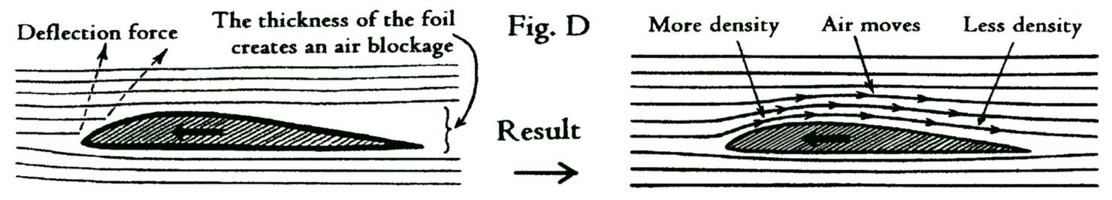

Fig. D, when an airfoil is moving, air at the front edge is compressed (positive dynamic pressure) and tends to rise. This upward force is resisted by the surrounding air, but it does decrease the air pressure on the top-rear of the airfoil (negative dynamic pressure). The pressure potential difference or motive force that is created forces the air to move faster from high to low pressure (equalize attempting). An amount of energy must be spent against the drag on the front edge to get a little lift on the top-rear which is minor and not enough to lift the plane at all. Currently, it is believed that air passing over a curve creates lift. If this is the case, how can stunt planes fly upside down? They are able to fly because the air is attacking under the wings and bodies like kites.

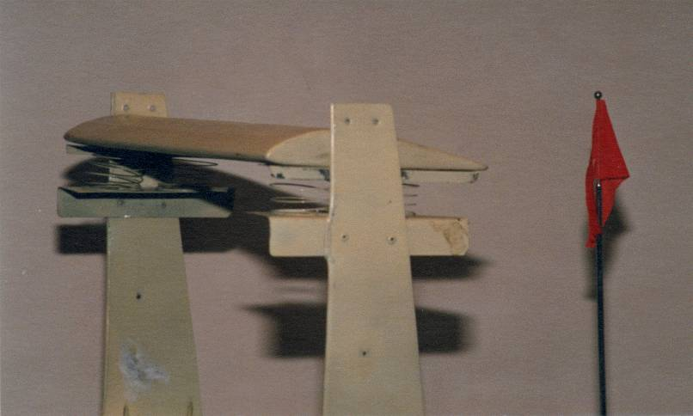

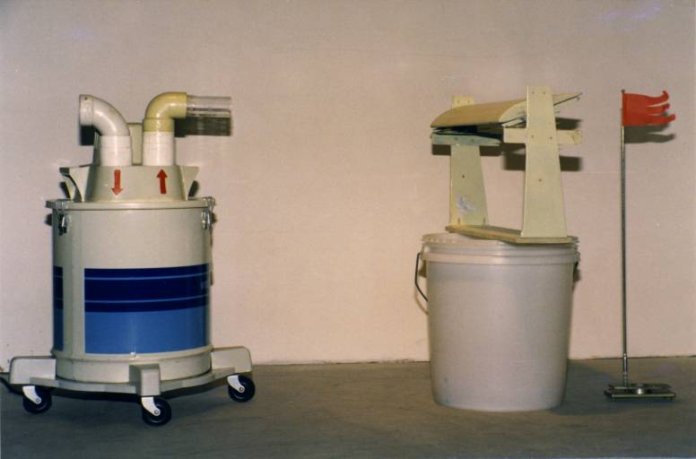

2 Above photos, demonstrate something different. Unlike an airplane wing that is fixed to the plane, an airfoil is suspended horizontally on four springs and is aligned with the air flow. When the air blower is switched on, the stream of air presses the front-edge down and raises the top-rear up. This emphasizes the explanation of Fig. D. on the previous page.
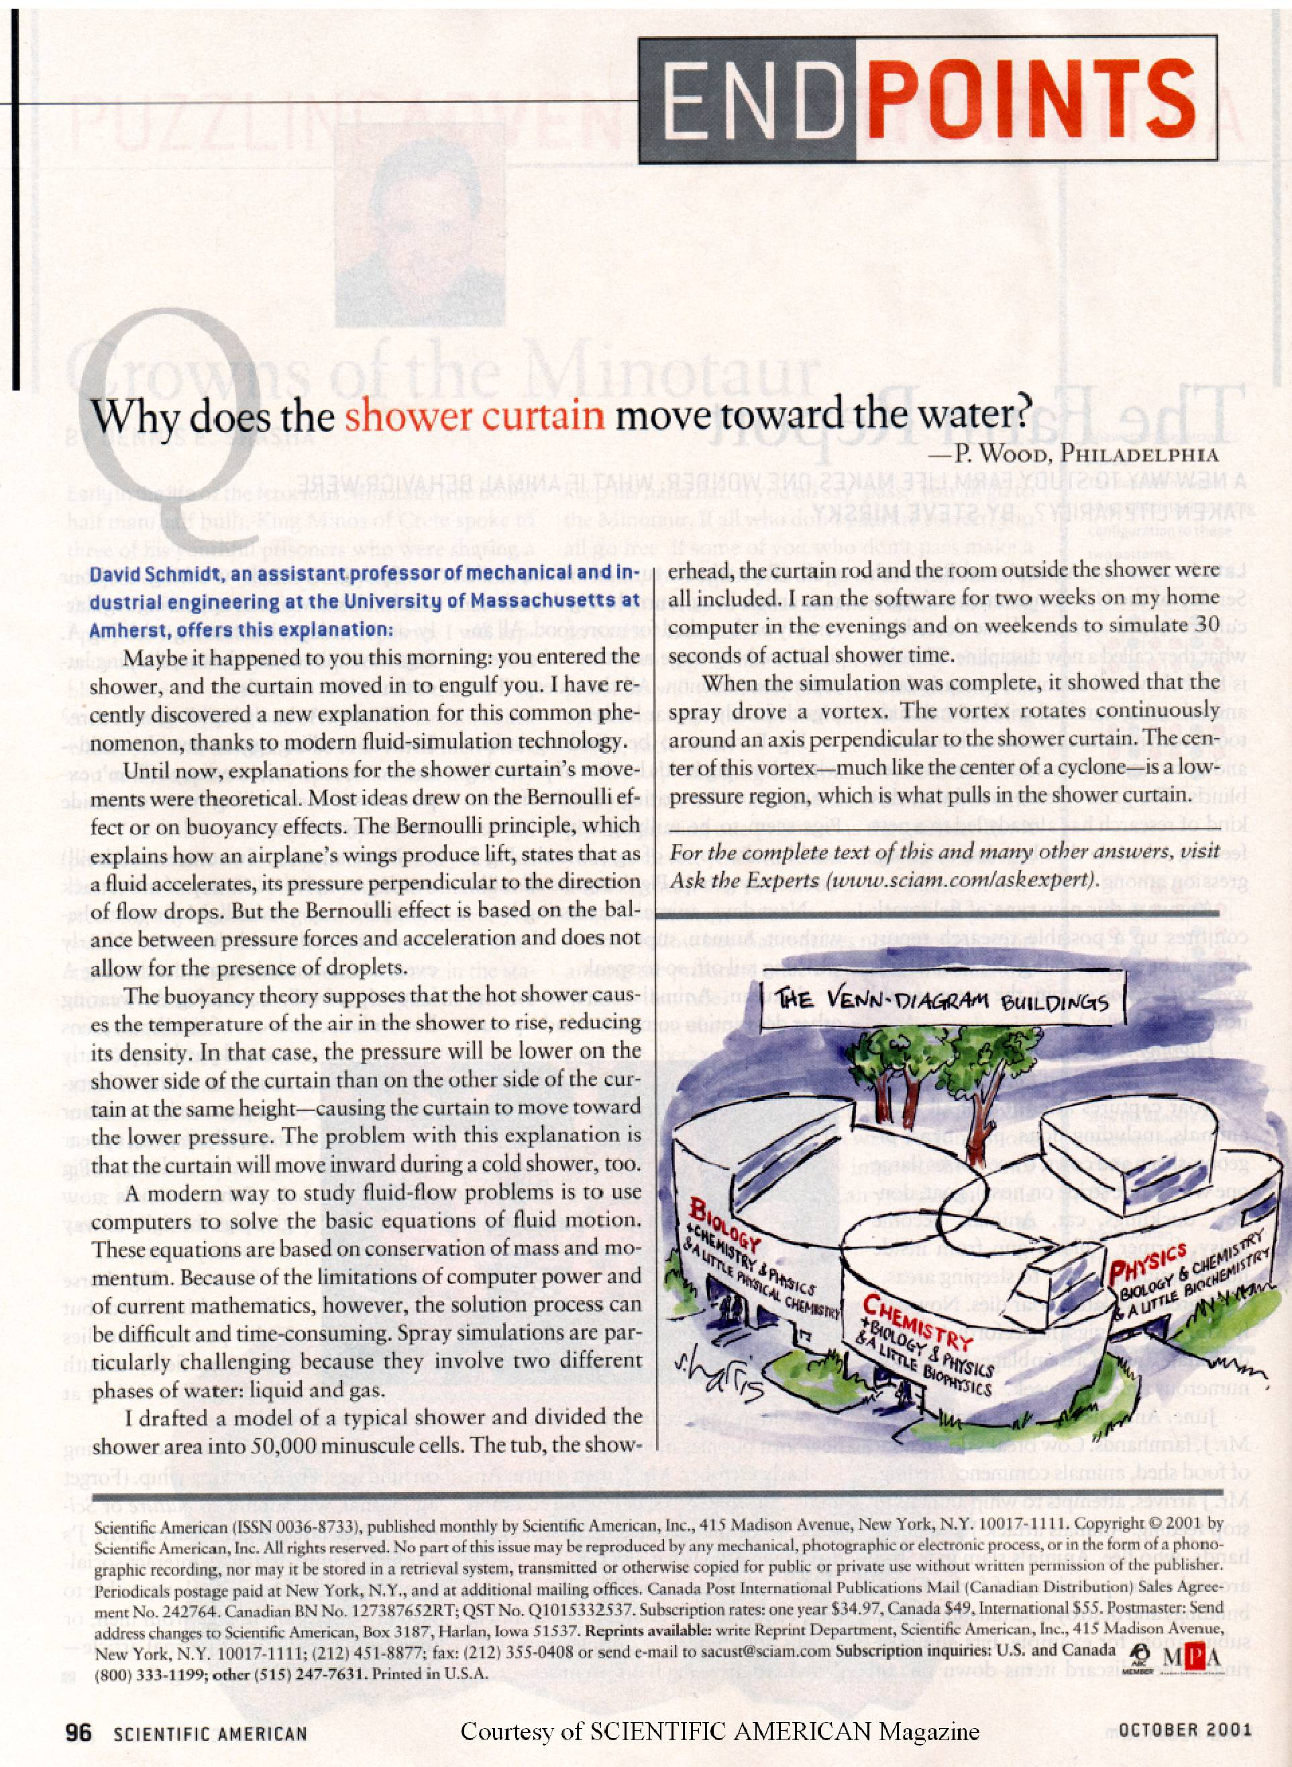
Why does the shower curtain move toward the water?

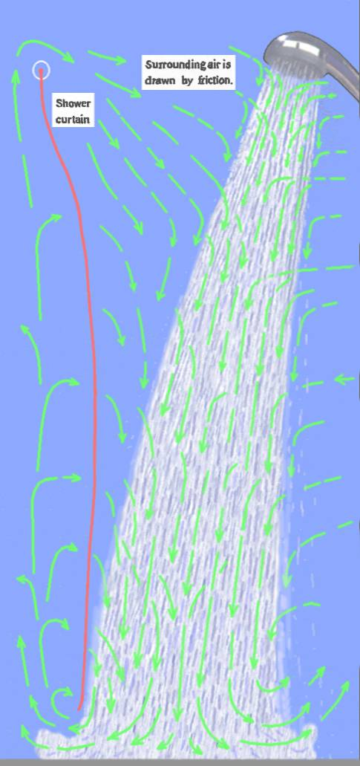

Refer to an article of the SCIENTIFIC AMERICAN Magazine October 2001 Volume 285 Number 4, Column ENDPOINTS Page 96, as shown on the previous page. David Schmidt at University of Massachusetts stated that he discovered the spray of the shower drove a vortex. The vortex rotates continuously around an axis perpendicular to the shower curtain. The center of this vortex-much like the center of a cyclone-is a low pressure region, which is what pulls in the shower certain.

David Schmidt was wrong. There is no such a vortex! What had been found is the current of the moving air around the shower. Frictional force has been neglected in this case. This is simple, and can be explained as follows:-

Left drawing: Under the influence of gravity, frictional force is always present. When the shower is running, the surrounding air is drawn by frictional force to travel along with the shower as represented by green arrows. This action creates a low pressure (negative dynamic pressure) all around the shower and pulls in the shower curtain (red line). That is all about.

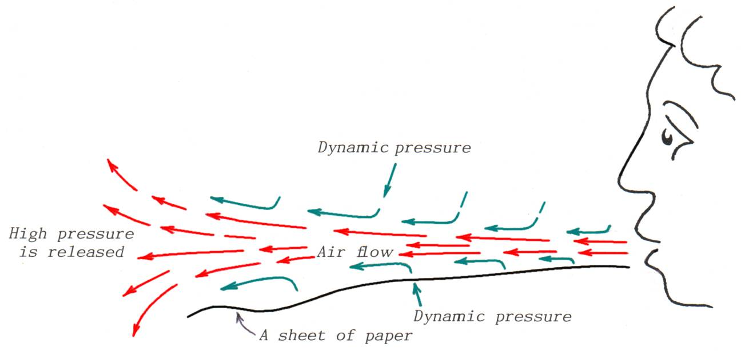

Similarly, holding a sheet of paper under the lips and blowing air causes the paper to lift under the stream of air. The compressed air from the mouth has higher pressure than the surrounding atmosphere. The compressed air moves forward (red arrows) to equalize its kinetic energy with the surrounding air and draws the surrounding air to travel along with the air stream by friction (green arrows). This action creates low pressure around the air stream and lifts the sheet of paper. Lift is not created by low pressure in the air as experts have said. This can be seen by using a flame and smoke. Also, deep well jet pumps work by the frictional and liquid-molecular-cohesive forces; not because of jet-water has a low pressure.

Please note: We should not always trust computers on this subject, since some incorrect data may have been installed.

It is commonly known that the center of a tornado has low pressure. Experts explain this by pointing out that the wind speed at the center of the tornado is high. They do so because they have learned this and never questioned it, but this is not the true reason. The true explanation for the low pressure in the core of a tornado is the centrifugal force that throws the air's molecules away from the center.

When a hurricane is formed on the surface of the ocean, a great amount of mist is produced by friction between the winds and the water. Since this mist has more mass than air molecules, the centrifugal force increases its power, the size of the hurricane increases and reaches to the top of the atmosphere. When it moves onto land where moisture is lacking, without this mist, the centrifugal force loses its power, and the winds of the hurricane subside.

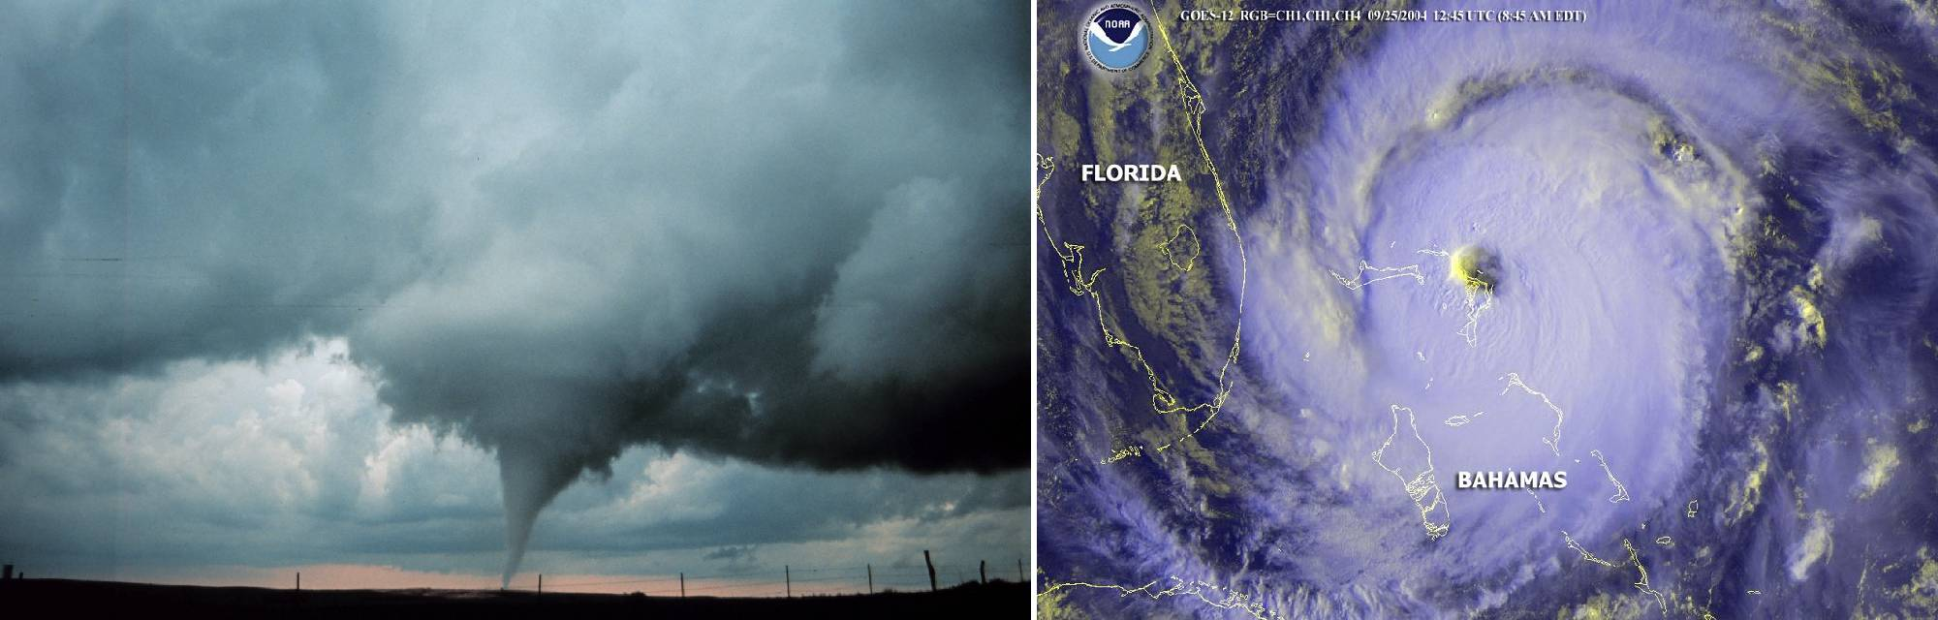

Images Courtesy of US National Oceanic and Atmospheric Administration

Reversing the action: Suppose a bullet is suspended motionless in the air. If a man runs into the bullet at the speed of a bullet, he will be wounded as though he had been shot.

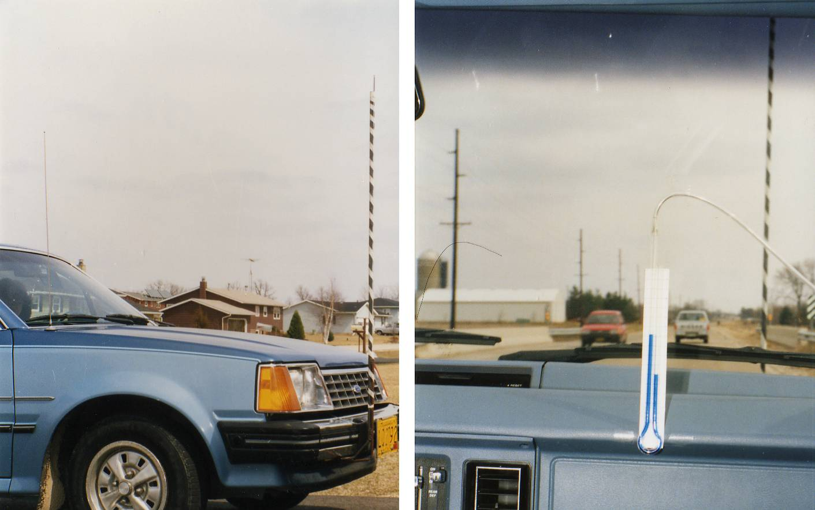

As shown in the above photos, I have reversed the process. An open-ended hose is taped to a pole attached to the front of a car. The other end is connected to a U-shaped tube which is partially filled with liquid and attached inside the car. When the car is driven, the pressure is lowered because some air is drawn out by friction between the stationary air at the tip of the pilot tube which is in contact with the passing air and creates the actions as described on the front cover. The liquid level changes from that observed in the non-moving car, which is essentially atmospheric pressure.

This experiment proves that the liquid level is not the pressure of the air that is in contact with the tip of the pilot tube during traveling. It is only the pressure of the pilot tube, the dynamic pressure.

In another experiment, I used a 1/16 inch outside diameter brass tube. I soldered one end shut and drilled a small hole near that end. I lengthened it with a larger tube to which I attached a plastic hose connected to a U-shaped tube. The left drawing on next page illustrates this apparatus. I partially filled the U-shaped tube with liquid and attached it to the inside of a car. With the assistance of a driver, I held the tube vertically outside of the car as we drove. I rotated the tube left and right around its axis. When the hole on the tip of the tube was facing the direction of travel, high pressure was produced in the tube due to the impact of the airs mass. While I slowly rotated the tube to the right or left, the pressure in the tube gradually decreased until the hole was at about 53.1 degrees from the direction of travel. The pressure became lower until the hole reached 90 degrees from the direction of travel, when it was at its minimum. When the tube was rotated so the hole was facing the opposite direction of travel, the pressure was still low. The high pressure produced by impact of airs mass is stronger than the low pressure produced by the frictional draw off. Coincidentally, the 53.1-degree angle is equal to the angle of a triangle with sides at a ratio of 3:4:5.

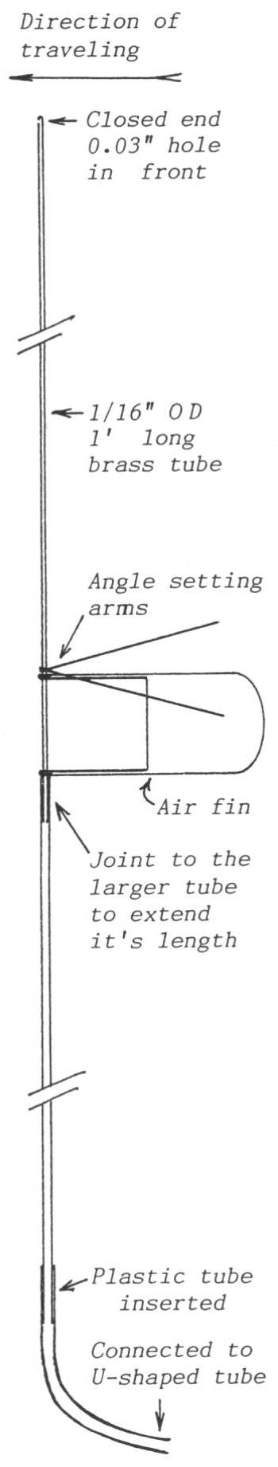
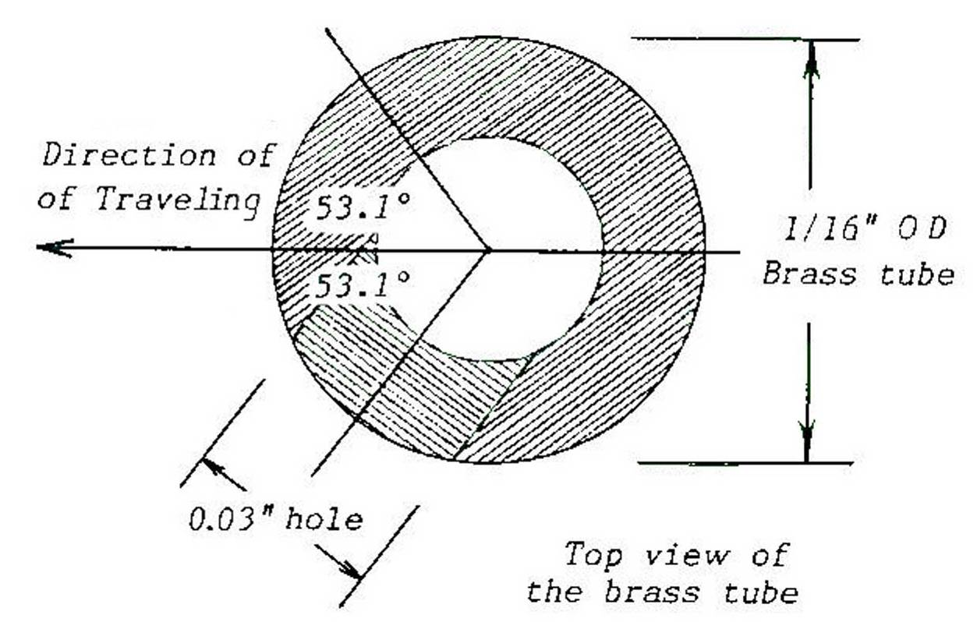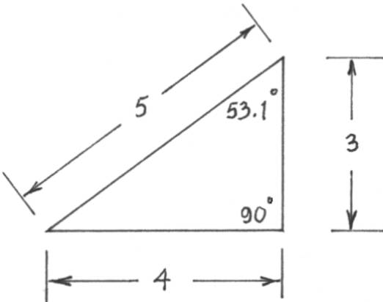

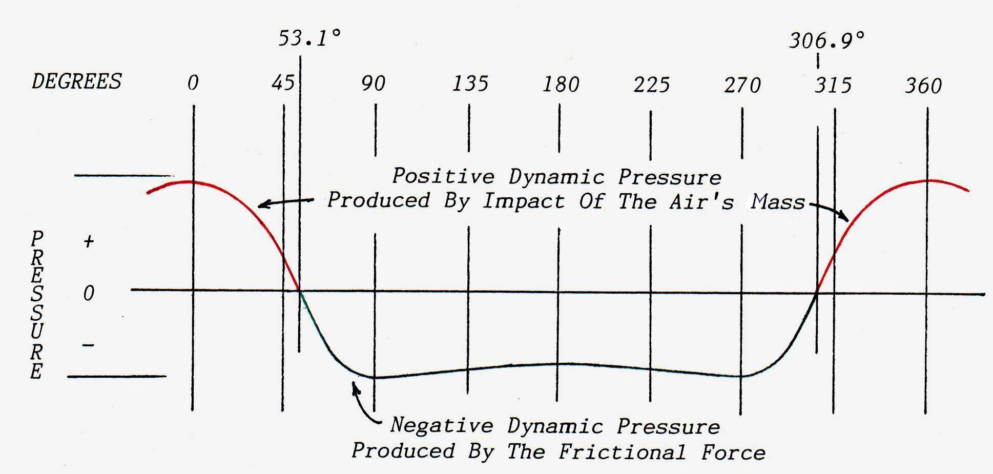
The graph shows that the liquid level changes as the tube is rotated during travel.
When the test tube is set at 53.1 degrees, the liquid level shows no change in pressure.

From my experiment, I have found that there is no dynamic pressure produced at 53.1 degrees from the direction of travel. In other words, it is the balance angle (Critical Angle) between positive and negative dynamic pressures. I used this method to measure the pressure of moving air and water flow in Venturi's constricted channel. The resulting measurements are consistent with the natural law of pressure equalization. The experimental design is alterable.
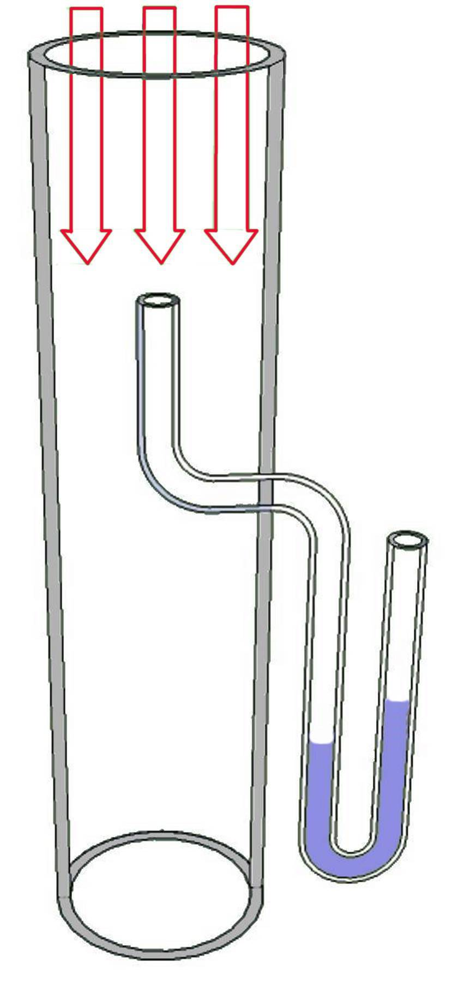

There is an existing instrument showing on the right. The reading is positive dynamic pressure of the pilot tube produced by impact of fluid-molecules, it tends to be Positive no matter the passing fluid has a high or low pressure (compressed or vacuumed). But the readings of Bernoulli & Venturi system are negative dynamic pressures and tend to be Negative. The readings of both systems are the functions of fluid speeds but they are not the pressure of the moving fluid!

The following photos depict using the new measuring method.

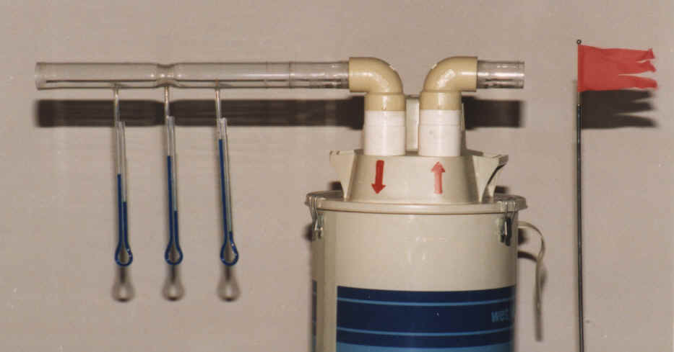

The vacuum machine produces low pressure at the input side. The liquid levels show the pressure is gradually decreasing and the pressure at the constriction is not the lowest among the three.

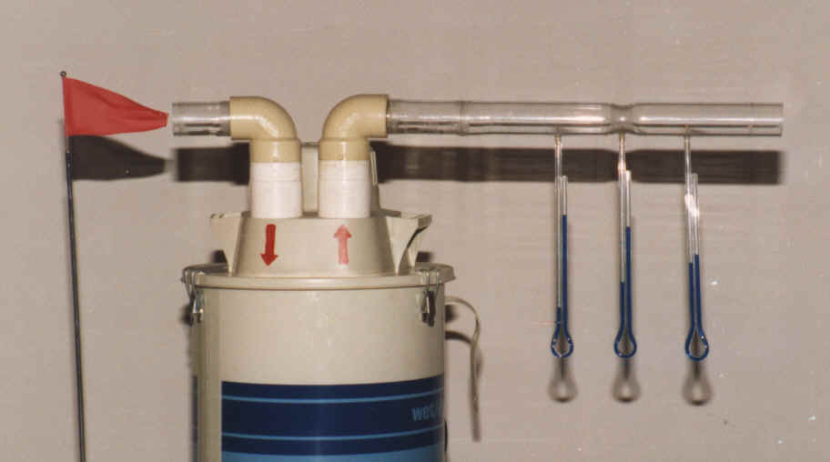

The liquid levels show the pressure of the moving air from the output side of the vacuum machine is high at the point of exit and gradually lowers as it leaves the tube.

Note: The liquid levels using the conventional method of demonstration always show the pressure is low both at the output and input sides of the vacuum machine.
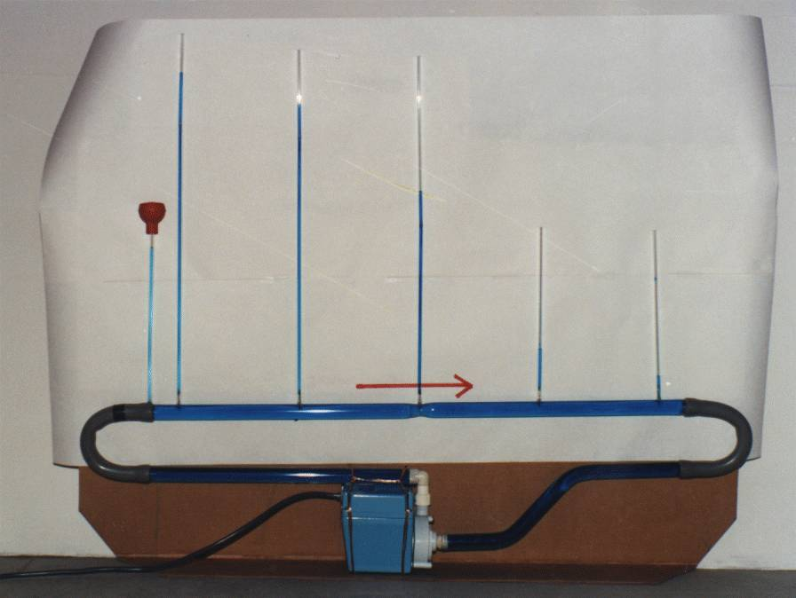

The tinted water is driven by an electric pump through the constriction in the closed loop. The measurements are consistent with the natural law of pressure equalization. Compare to the column capped by the red reserve pot which uses the old method of measuring and the pressure is not the lowest at the point of constriction. Please note the brass measuring tips at the joints of the channel and columns on the above photo and the two photos on the previous page.

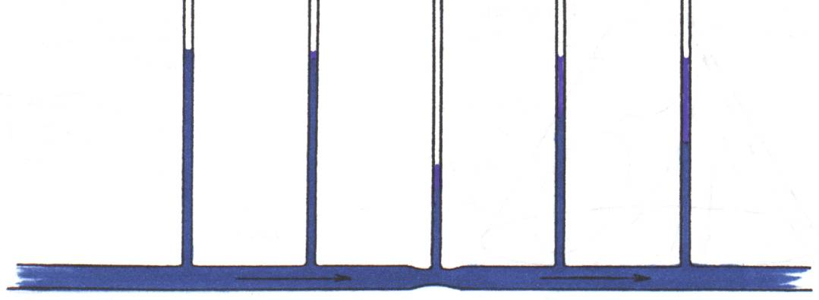

The above drawing shows the liquid levels produced using the accepted method of demonstration. If clear water is used, dropping colored powder into the columns during flow would allow us to see actions in columns.

Presently, Fluid Dynamics is very complicated and not always intuitive because we misunderstand the phenomenon of the Venturi Effect. The frictional, liquid molecular-cohesive and motive forces are the significant natural forces those had been out of Bernoulli’s mind and neglected, using the wrong method to measure the pressure of the moving fluid; the liquid levels do not indicate the pressure of the moving fluid. Since then the theory of Fluid Dynamics had been put in a false position due to an incorrect notion. Fluid Dynamics is in accord with natural laws and can be defined as scientific configuration. Bernoulli's laws and equations are used in solving problems involving fluids in motion with somewhat compromise. However, Bernoulli’s Principle mistakes! The explanation that described how the air plane wings create lift is unbelievable as we see stunt planes fly upside down; the curves are down below and they go!! Also radio control helicopter’s rotors have the same design as airplane wings without flaps also are able to make inverted flight too!!! Please see the demonstration photos on next page.
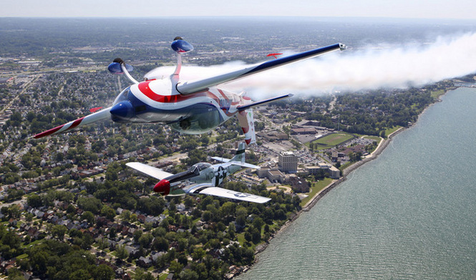

Courtesy of Cleveland National Air-show: Inverted flight flown by John Klat

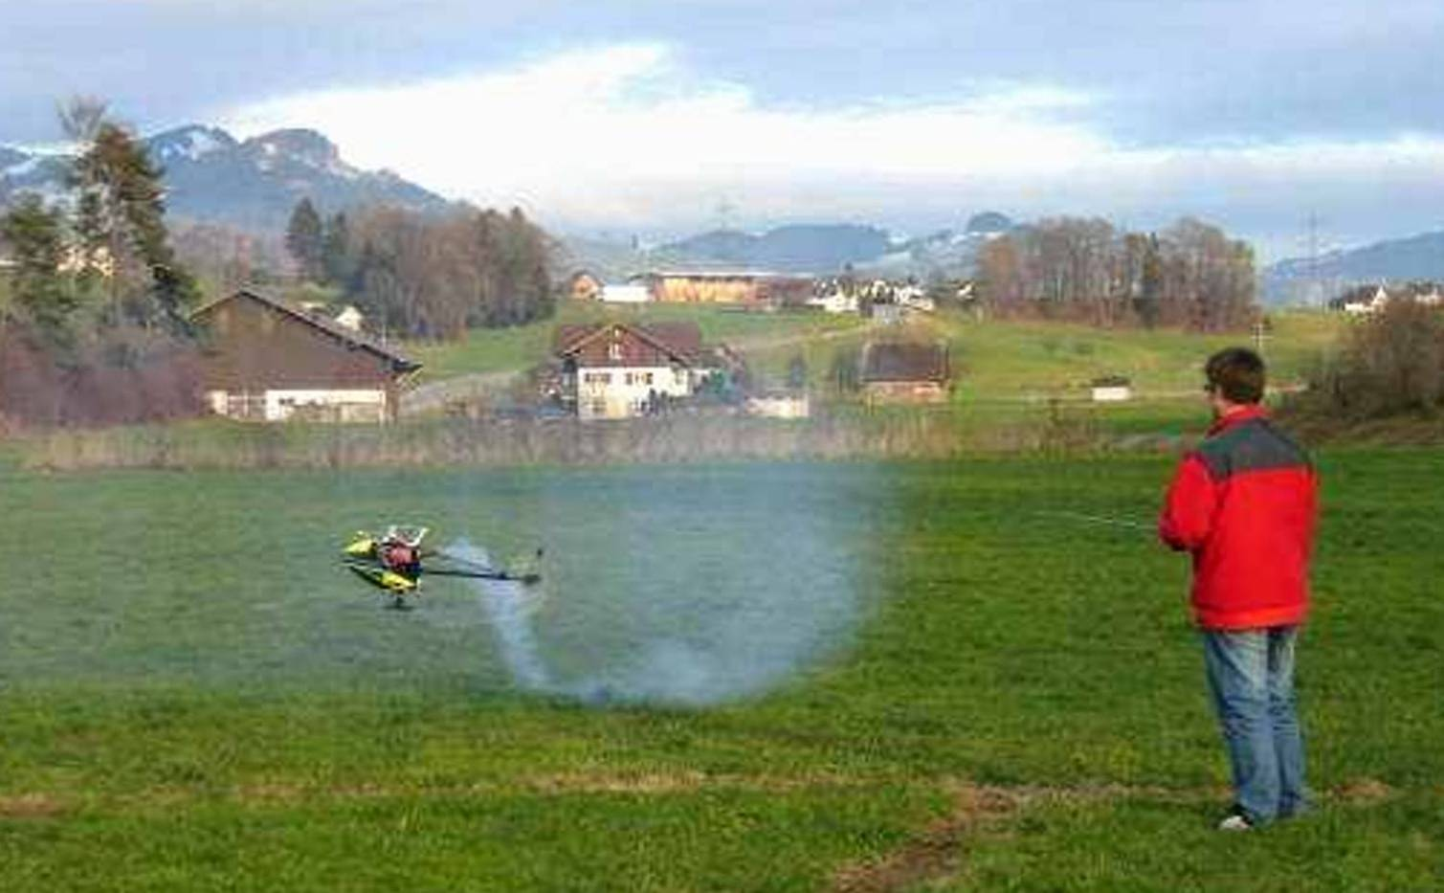

Courtesy of Roger Buerge of Switzerland: Demonstrator.

I performed my experiments from 1985–1986. *We should do a new research and setting a new standard for Fluid Dynamics’ Theory and Formulas*
Thank you for reading.
Mity Wongkit mitywongkit@sbcglobal.net piacwonkit@gmail.com

My website is clean, you can download safely. Please add your comment or questions. THANKS

